* **Mass Guns Seized and NYPD Increased Measures:**

**How Big Data Is Helping the NYPD Solve Crimes Faster** Thomas Davenport -

<http://fortune.com/2016/07/17/big-data-nypd-situational-awareness/>

**Here’s some of the 15,000 guns the NYPD seized since 2013** Tina Moore-Chris Perez –

<http://nypost.com/2016/10/26/this-is-how-many-guns-the-nypd-has-seized-so-far-this-year/>]

|  |  |
| --- | --- |
| Year | Number of Guns Seized |
| 2011 | 12-20 |
| 2012 | 100 |
| 2013 | 250 |
| 2014 | 306 |
| 2015 | 608 by first quarter of 2015 |

August 2013 - More than 250 illegal guns have been seized by the New York City Police Department in the largest gun bust in the city's history, Mayor Michael Bloomberg announced Monday. <http://www.cnn.com/2013/08/19/justice/new-york-illegal-guns/>

October 2012: **Over 100 Firearms Seized In Huge Manhattan Gun Bust**

[**http://nypost.com/2012/10/13/64-year-old-12-others-arrested-in-gun-smuggling-bust/**](http://nypost.com/2012/10/13/64-year-old-12-others-arrested-in-gun-smuggling-bust/)

**2011 : More than a dozen guns**

**https://cityroom.blogs.nytimes.com/2011/10/25/officers-accused-of-smuggling-guns-in-federal-corruption-case/**

* **Crimes Decrease after 2011 because of Unemployment rate decrease**

Decrease unemployment rate

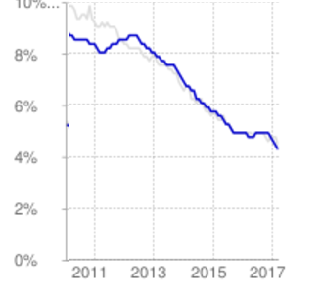

<http://www.deptofnumbers.com/unemployment/new-york/>

<https://fred.stlouisfed.org/series/NYUR>

* **Increase in employment rate**
  + **An overall increase in employment in New York City.** Post 2011, employment (per thousands of persons ) increased at a steady rate as shown by the data (**nyc-employment.csv**) obtained from the Economic Research Department of the Federal Reserve of St.Louis and processed in **nyc-employment.ipynb**.   
    